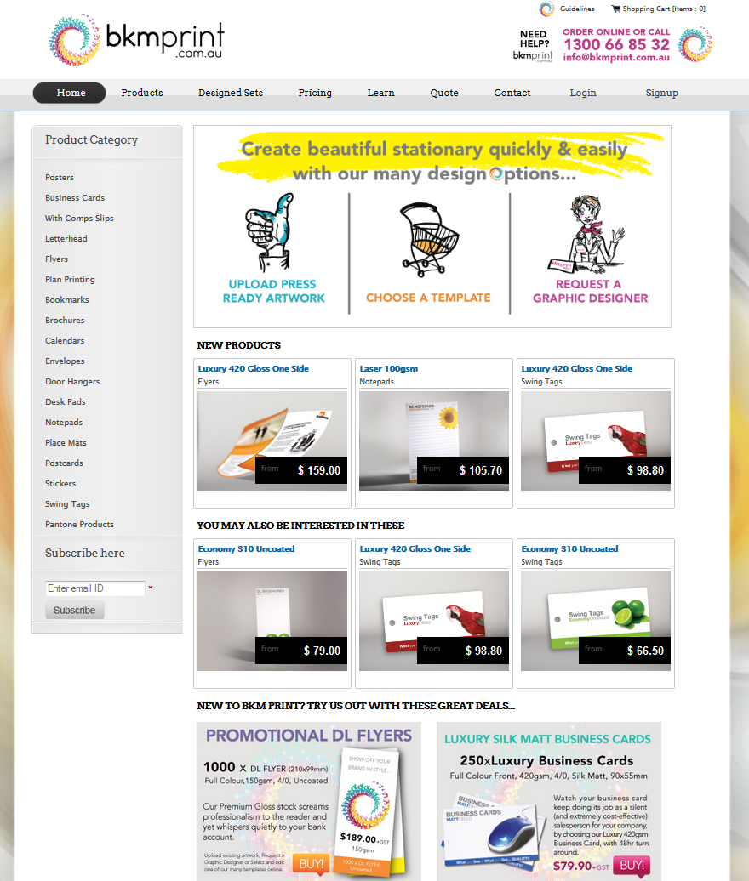

<http://www.bkmprint.com.au/>

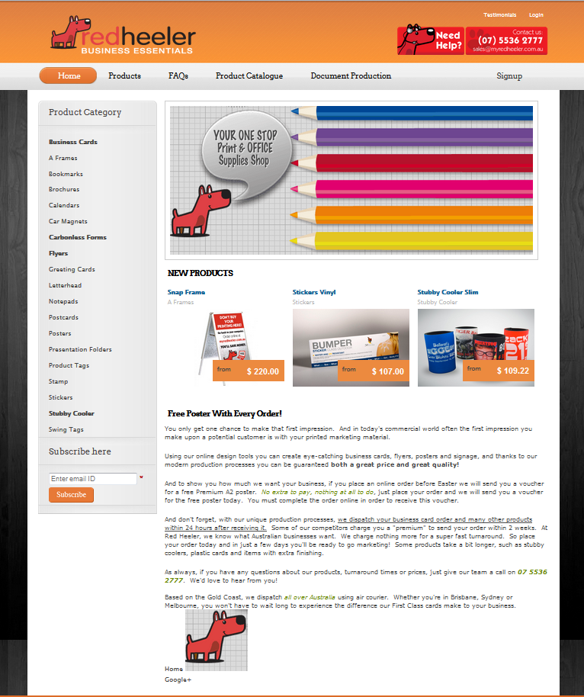

<http://www.myredheeler.com.au/>

**Customer Registration**

Editing the confirmation email through the Admin Dashboard

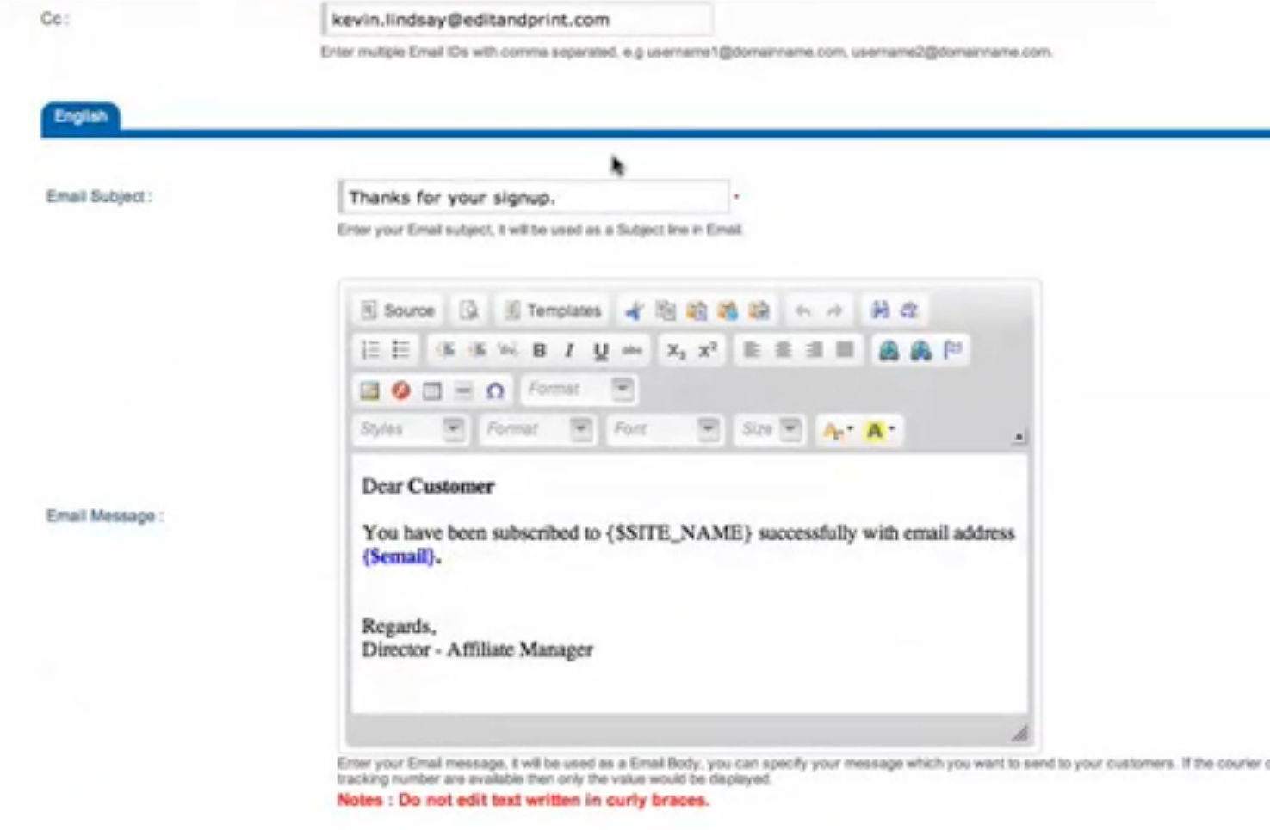

**Online Template Use**

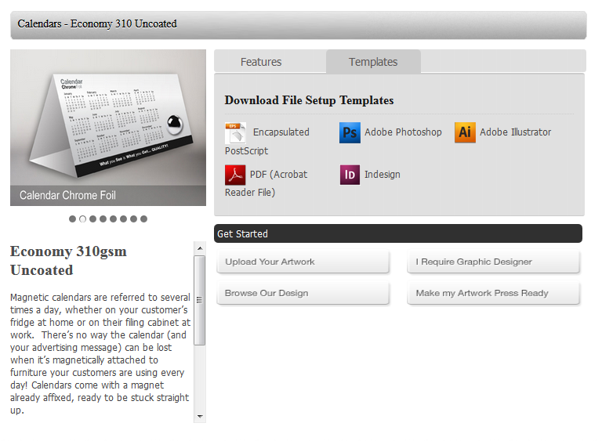

**Upload Custom Design**

Customers can upload their own images or PDF to use for a custom design.

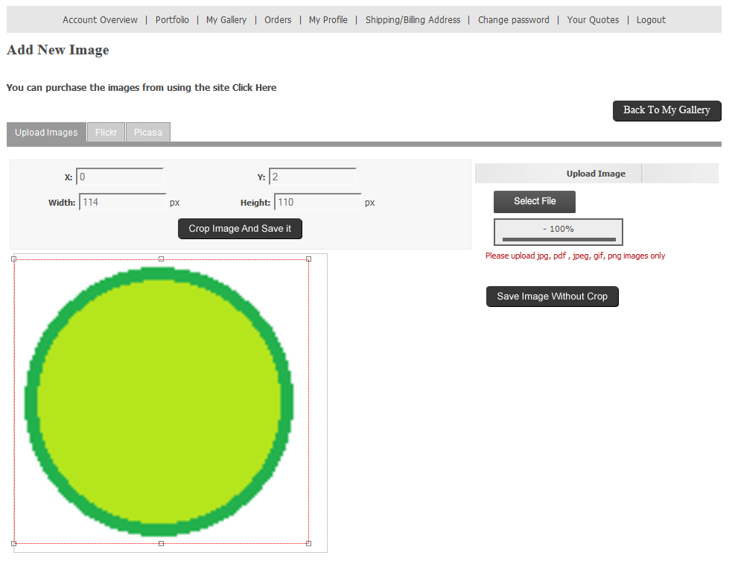

Customers can design their own template or edit a supplied template and create their custom design in Designer Studio. Designer Studio runs on Flash Player (may not be compatible with some browsers)

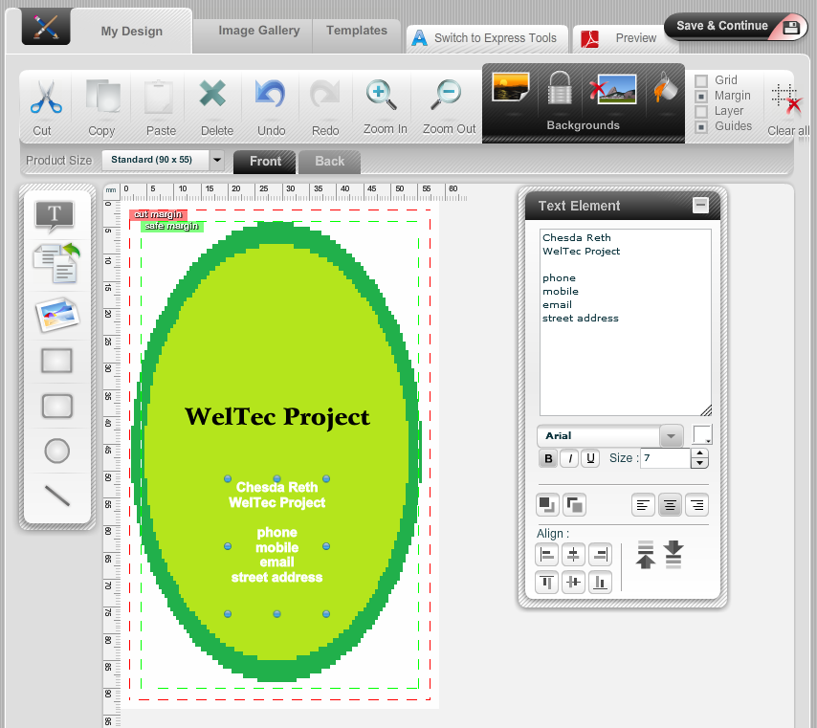

**Design assistance request**

Customers can request help from a graphic designer

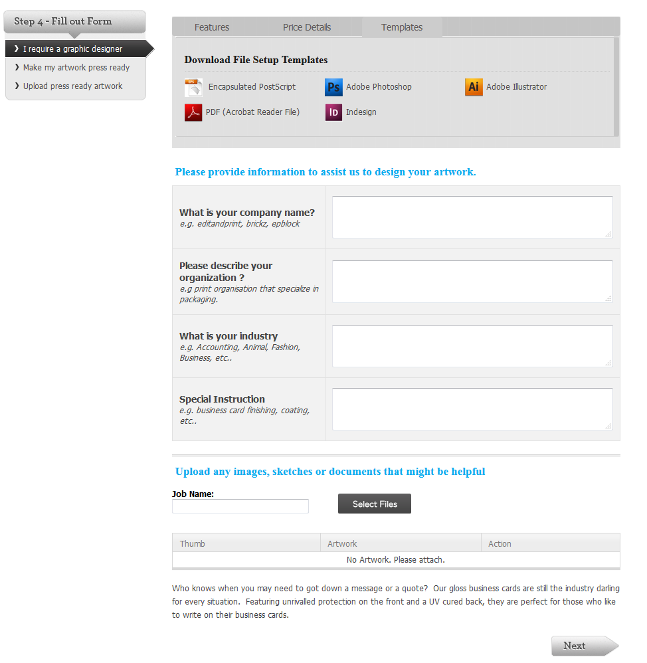

**Online information Request**

Method 1: Contact Us from the menu tab

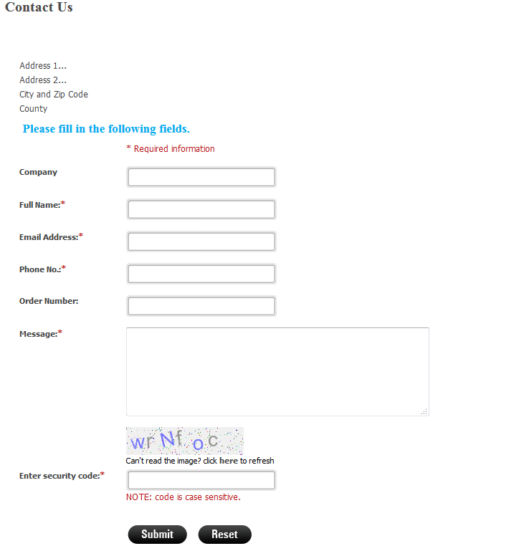

Method 2: In the footer of every page

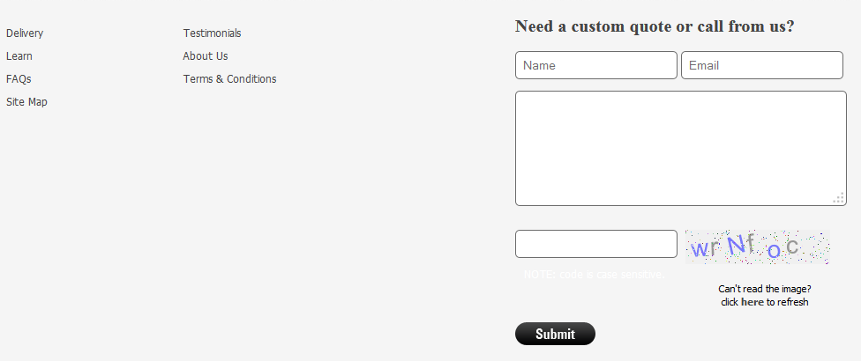

**Shopping Cart**

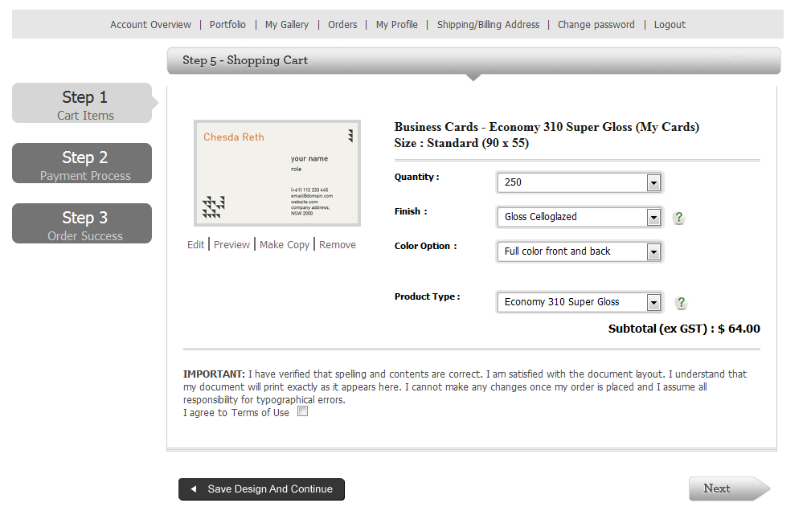

**Fixed Pricing Guide**

Prices for each type of product

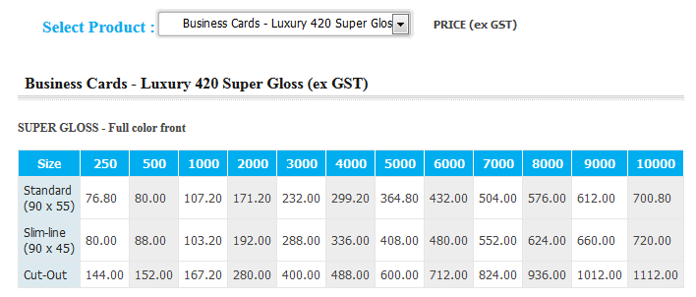

**Dynamically calculated price**

Prices are calculated based on the options chosen.

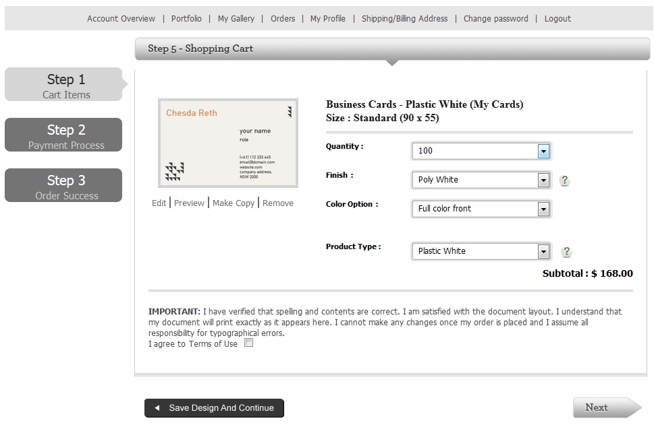

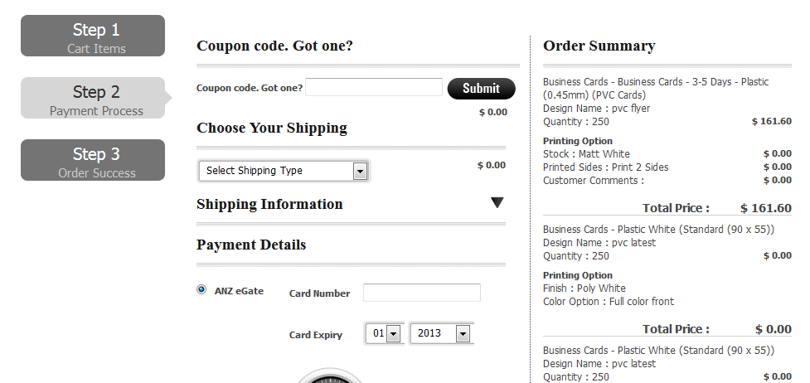

**Customer Reorder**

Customers Designs are saved in their Portfolio and they can be reordered

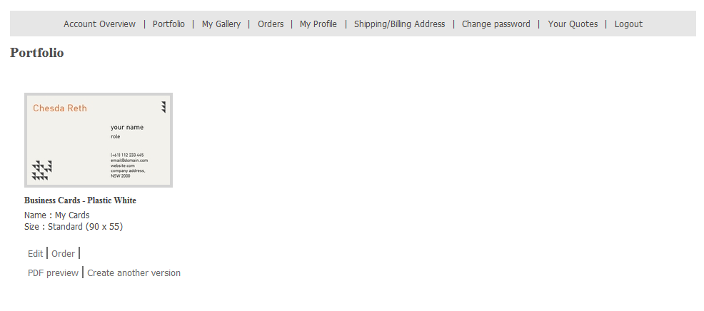

**Credit Card Payment**

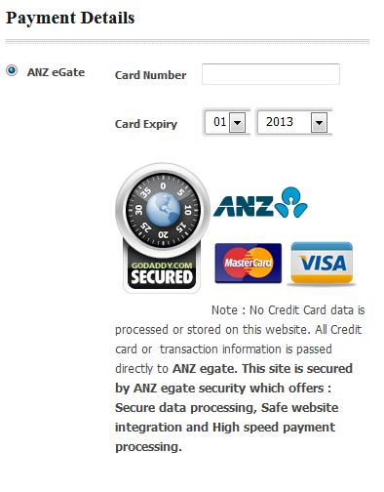

**History of Quotes**

Quote status, price, and proofing can be viewed in the Customer History.

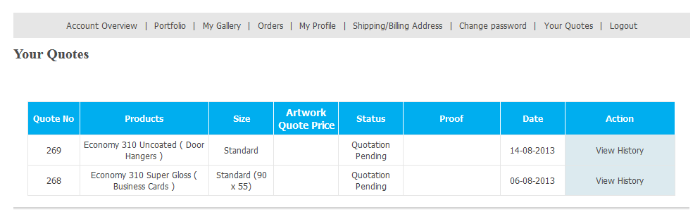

**Proofing**

Customers can preview their print ready artwork in a PDF file

